Assignment

Q1.

**Mapset:**

A31MPS1 DFHMSD TYPE=&SYSPARM,MODE=INOUT,CTRL=(FREEKB,FRSET), X

LANG=COBOL,TIOAPFX=YES, X

STORAGE=AUTO

A31MPS1 DFHMDI SIZE=(24,80), X

LINE=01,COLUMN=01

DFHMDF POS=(03,20),LENGTH=20,ATTRB=PROT, X

INITIAL='WELCOME TO CAPGEMINI'

DFHMDF POS=(04,20),LENGTH=20,ATTRB=PROT, *

INITIAL='*********************'

DFHMDF POS=(08,15),LENGTH=08,ATTRB=PROT, *

INITIAL='DATE :'

DFHMDF POS=(10,15),LENGTH=08,ATTRB=PROT, X

INITIAL='TIME :'

DATE DFHMDF POS=(08,24),LENGH=10, X

INITIAL='__________', X

ATTRB=(UNPROT,NORM,IC)

DFHMDF POS=(08,35),LENGTH=01,ATTRB=ASKIP

TIME DFHMDF POS=(10,24), X

LENGTH=08, X

INITIAL='________', X

ATTRB=(UNPROT,NORM)

DFHMDF POS=(10,33),LENGTH=01,ATTRB=PROT

DFHMDF POS=(14,15),LENGTH=09,ATTRB=PROT, X

INITIAL='MESSAGE :'

MSGA DFHMDF POS=(14,25), X

LENGTH=25, X

INITIAL='_________________________', X

ATTRB=(UNPROT,NORM)

DFHMDF POS=(20,10), X

LENGTH=40, X

INITIAL='F3:EXIT F12:RETRIEVE DATE F5:REFRESH', X

ATTRB=(PROT,BRT)

DFHMSD TYPE=FINAL

END

**Program**

IDENTIFICATION DIVISION.

PROGRAM-ID. A31PGM1.

ENVIRONMENT DIVISION.

DATA DIVISION.

WORKING-STORAGE SECTION.

COPY A31MPS1.

COPY DFHAID.

01 WS-MSG PIC X(20) VALUE SPACES.

01 WS-COMM PIC X.

01 WS-DATE PIC X(10).

01 WS-TIME PIC X(8).

01 WS-TSTAMP PIC S9(15) COMP-3.

LINKAGE SECTION.

01 DFHCOMMAREA PIC X.

*

PROCEDURE DIVISION.

0000-MAIN-PARA.

IF EIBCALEN = 0

MOVE LOW-VALUES To A31MPS1O

PERFORM 2000-SENDPARA

PERFORM 2100-RETURNPARA

ELSE

PERFORM 1000-EVALUATPARA.

1000-EVALUATPARA.

EVALUATE EIBAID

WHEN DFHPF5 PERFORM 4000-REFERSHPARA

WHEN DFHPF3 PERFORM 5000-EXITPARA

WHEN DFHPF12 PERFORM 3000-DATEPARA

WHEN OTHER PERFORM 6000-ERRORPARA

END-EVALUATE.

2000-SENDPARA.

EXEC CICS

SEND MAP('A31MPS1') MAPSET('A31MPS1')

ERASE

END-EXEC.

2100-RETURNPARA.

EXEC CICS

RETURN TRANSID('A321') COMMAREA(WS-COMM)

END-EXEC.

4000-REFERSHPARA.

MOVE LOW-VALUES To A31MPS1O

PERFORM 2000-SENDPARA .

PERFORM 3000-DATEPARA.

PERFORM 2100-RETURNPARA .

5000-EXITPARA.

MOVE 'THANK U' TO WS-MSG.

EXEC CICS

SEND FROM(WS-MSG)

ERASE

END-EXEC.

EXEC CICS

RETURN

END-EXEC.

6000-ERRORPARA.

MOVE 'INVALID KEY ' TO MSGAO.

PERFORM 2000-SENDPARA.

PERFORM 2100-RETURNPARA.

3000-DATEPARA.

MOVE LOW-VALUES TO A31MPS1O.

EXEC CICS

ASKTIME ABSTIME(WS-TSTAMP)

END-EXEC.

EXEC CICS

FORMATTIME ABSTIME(WS-TSTAMP)

DDMMYYYY(WS-DATE)

DATESEP('/')

TIME(WS-TIME)

TIMESEP(':')

END-EXEC.

MOVE WS-DATE TO DATEO.

MOVE WS-TIME TO TIMEO.

PERFORM 2000-SENDPARA.

PERFORM 2100-RETURNPARA.

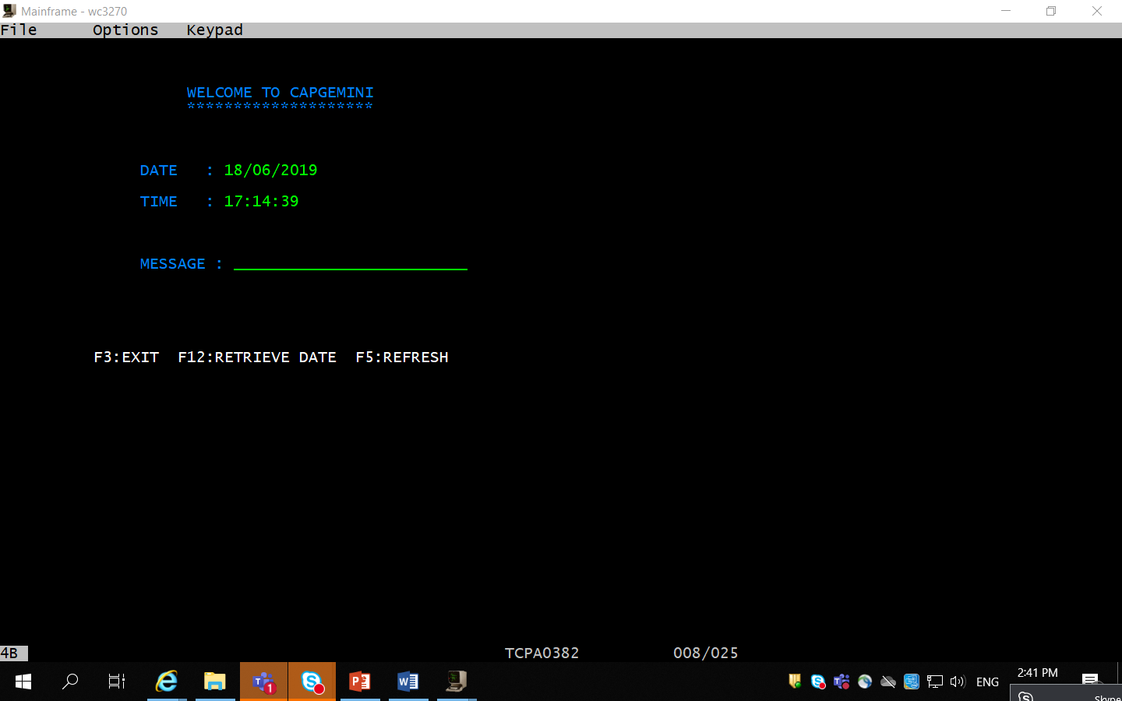

Q2. Calculator

**Mapset**

A32MPS2 DFHMSD TYPE=&SYSPARM,MODE=INOUT,CTRL=(FREEKB,FRSET), X

LANG=COBOL,TIOAPFX=YES, X

STORAGE=AUTO

A32MPS2 DFHMDI SIZE=(24,80), X

LINE=01,COLUMN=01

DFHMDF POS=(03,20),LENGTH=20,ATTRB=PROT, X

INITIAL='********************'

DFHMDF POS=(04,20),LENGTH=10,ATTRB=PROT, X

INITIAL='CALCULATOR'

DFHMDF POS=(05,20),LENGTH=20,ATTRB=PROT, *

INITIAL='********************'

DFHMDF POS=(08,20),LENGTH=14,ATTRB=PROT, *

INITIAL='ENTER NUMBER 1'

NUM1 DFHMDF POS=(08,35), X

LENGTH=05, X

INITIAL='_____', X

ATTRB=(UNPROT,NORM,IC)

DFHMDF POS=(08,41),LENGTH=01,ATTRB=ASKIP

DFHMDF POS=(10,20),LENGTH=14,ATTRB=PROT, X

INITIAL='ENTER NUMBER 2'

NUM2 DFHMDF POS=(10,35), X

LENGTH=05, X

INITIAL='_____', X

ATTRB=(UNPROT,NORM)

DFHMDF POS=(13,41),LENGTH=01,ATTRB=ASKIP

DFHMDF POS=(15,20),LENGTH=11,ATTRB=PROT, X

INITIAL='OPERATION :'

NUM3 DFHMDF POS=(15,33), X

LENGTH=01, X

INITIAL='_', X

ATTRB=(UNPROT,NORM)

DFHMDF POS=(15,35),LENGTH=01,ATTRB=ASKIP

DFHMDF POS=(17,15),LENGTH=18,ATTRB=PROT, X

INITIAL='CALCULATED VALUE :'

CALC DFHMDF POS=(17,25), X

LENGTH=10, X

INITIAL='__________', X

ATTRB=(UNPROT,NORM)

DFHMDF POS=(20,10), X

LENGTH=38, X

INITIAL='F3:EXIT F12:RETRIEVE DATE F5:REFRESH', X

ATTRB=(PROT,BRT)

DFHMSD TYPE=FINAL

END

**Program**

IDENTIFICATION DIVISION.

PROGRAM-ID. A32PGM2.

ENVIRONMENT DIVISION.

DATA DIVISION.

WORKING-STORAGE SECTION.

COPY A32MPS2.

COPY DFHAID.

01 WS-COMM PIC X.

01 WS-MSG PIC X(20) VALUE SPACES.

01 WS-NUM1 PIC 9(05).

01 WS-NUM2 PIC 9(05).

01 WS-CALC PIC 9(10).

01 WS-COM PIC X(01).

LINKAGE SECTION.

01 DFHCOMMAREA PIC X.

*

PROCEDURE DIVISION.

0000-MAIN-PARA.

IF EIBCALEN = 0

MOVE LOW-VALUES To A32MPS2O

PERFORM 2000-SENDPARA

PERFORM 2100-RETURNPARA

ELSE

PERFORM 1000-EVALUATPARA.

1000-EVALUATPARA.

EVALUATE EIBAID

WHEN DFHPF5 PERFORM 4000-REFERSHPARA

WHEN DFHPF3 PERFORM 5000-EXITPARA

WHEN DFHPF12 PERFORM 3000-CALCPARA

WHEN OTHER PERFORM 6000-ERRORPARA

END-EVALUATE.

2000-SENDPARA.

EXEC CICS

SEND MAP('A32MPS2') MAPSET('A32MPS2')

ERASE

END-EXEC.

2100-RETURNPARA.

EXEC CICS

RETURN TRANSID('A322') COMMAREA(WS-COMM)

END-EXEC.

4000-REFERSHPARA.

MOVE LOW-VALUES To A32MPS2O

PERFORM 2000-SENDPARA .

PERFORM 2100-RETURNPARA .

5000-EXITPARA.

MOVE 'THANK U' TO WS-MSG.

EXEC CICS

SEND FROM(WS-MSG)

ERASE

END-EXEC.

EXEC CICS

RETURN

END-EXEC.

6000-ERRORPARA.

MOVE 0 TO CALCO.

PERFORM 2000-SENDPARA.

PERFORM 2100-RETURNPARA.

3000-CALCPARA.

MOVE LOW-VALUES TO A32MPS2O.

EXEC CICS RECEIVE

MAP ('A32MPS2')

MAPSET ('A32MPS2')

INTO (A32MPS2I)

END-EXEC.

MOVE NUM1I TO WS-NUM1.

MOVE NUM2I TO WS-NUM2.

MOVE NUM3I TO WS-COM.

EVALUATE WS-COM

WHEN "+"

ADD WS-NUM1 TO WS-NUM2 GIVING WS-CALC

WHEN "-"

COMPUTE WS-CALC = WS-NUM1 - WS-NUM2

WHEN "*"

COMPUTE WS-CALC = WS-NUM1 * WS-NUM2

WHEN "/"

COMPUTE WS-CALC = WS-NUM1 / WS-NUM2

WHEN OTHER

PERFORM 6000-ERRORPARA

END-EVALUATE.

MOVE WS-CALC TO CALCO.

EXEC CICS SEND

MAP ('A32MPS2')

MAPSET ('A32MPS2')

FROM (A32MPS2O)

ERASE

END-EXEC.

PERFORM 2000-SENDPARA.

PERFORM 2100-RETURNPARA.

Q3.

A32MPS3 DFHMSD TYPE=&SYSPARM,MODE=INOUT,CTRL=(FREEKB,FRSET), X

LANG=COBOL,TIOAPFX=YES, X

STORAGE=AUTO

A32MPS3 DFHMDI SIZE=(24,80), X

LINE=01,COLUMN=01

DFHMDF POS=(03,35),LENGTH=17,ATTRB=PROT, X

INITIAL='EMPLOYEE DETAILS:'

DFHMDF POS=(04,35),LENGTH=17,ATTRB=PROT, X

INITIAL='-----------------'

DFHMDF POS=(05,50),LENGTH=08,ATTRB=PROT, X

INITIAL='DATE :'

DFHMDF POS=(06,50),LENGTH=10,ATTRB=PROT, *

INITIAL='TIME :'

DFHMDF POS=(09,05),LENGTH=09,ATTRB=PROT, *

INITIAL='EMP NO : '

DFHMDF POS=(11,05),LENGTH=09,ATTRB=PROT, *

INITIAL='NAME :'

DFHMDF POS=(13,05),LENGTH=09,ATTRB=PROT, *

INITIAL='DEPT :'

DATE DFHMDF POS=(05,60),LENGTH=10,ATTRB=(UNPROT,NORM), *

INITIAL='__________'

TIME DFHMDF POS=(06,60),LENGTH=08,ATTRB=(UNPROT,NORM), *

INITIAL='________'

EMPNO DFHMDF POS=(09,15), X

LENGTH=05, X

ATTRB=(UNPROT,NORM,IC), X

INITIAL='_____'

DFHMDF POS=(09,21),LENGTH=1,ATTRB=ASKIP

NAME DFHMDF POS=(11,15),LENGTH=15, X

ATTRB=(UNPROT,NORM), X

INITIAL='_______________'

DFHMDF POS=(11,31),LENGTH=1,ATTRB=ASKIP

DEPT DFHMDF POS=(13,15),LENGTH=06,ATTRB=(UNPROT,NORM), X

INITIAL='______'

DFHMDF POS=(18,05),LENGTH=09,ATTRB=PROT, X

INITIAL='MESSAGE :'

MSG DFHMDF POS=(18,15), X

LENGTH=25, X

ATTRB=(UNPROT,NORM), X

INITIAL='_______________________'

DFHMDF POS=(22,15), X

LENGTH=40, X

ATTRB=(PROT,BRT), X

INITIAL='F1:READ ENTER:WRITE F3:EXIT F5:REFRESH'

DFHMDF POS=(23,20), X

LENGTH=40, X

ATTRB=(PROT,BRT), X

INITIAL='F4:UPDATE F6:DELETE'

DFHMSD TYPE=FINAL

END

**Program**

IDENTIFICATION DIVISION.

PROGRAM-ID. A32PGM3.

ENVIRONMENT DIVISION.

DATA DIVISION.

WORKING-STORAGE SECTION.

COPY A32MPS3.

COPY DFHAID.

01 WS-MSG PIC X(20) VALUE SPACES.

01 WS-COMM PIC X.

01 WS-DATE PIC X(10).

01 WS-TIME PIC X(8).

01 WS-TSTAMP PIC S9(15) COMP-3.

01 WS-RESP PIC S9(08) COMP.

01 WS-RESPO PIC S9(08) COMP.

01 WS-RES PIC S9(08) COMP.

01 EMPREC.

05 EMPNO PIC 9(05).

05 EMPNAME PIC X(15).

05 EMPDEPT PIC X(06).

05 FILLER PIC X(54).

LINKAGE SECTION.

01 DFHCOMMAREA PIC X.

*

PROCEDURE DIVISION.

0000-MAIN-PARA.

IF EIBCALEN = 0

MOVE LOW-VALUES To A32MPS3O

PERFORM 2000-SENDPARA

PERFORM 2100-RETURNPARA

ELSE

PERFORM 1000-EVALUATPARA.

1000-EVALUATPARA.

EVALUATE EIBAID

WHEN DFHPF1 PERFORM 7010-READPARA

WHEN DFHPF4 PERFORM 7030-UPDATEPARA

WHEN DFHENTER PERFORM 7020-WRITEPARA

WHEN DFHPF5 PERFORM 4000-REFRESHPARA

WHEN DFHPF3 PERFORM 5000-EXITPARA

WHEN DFHPF6 PERFORM 7040-DELETEPARA

WHEN OTHER PERFORM 6000-ERRORPARA

END-EVALUATE.

2000-SENDPARA.

PERFORM 3000-DATEPARA.

EXEC CICS

SEND MAP('A32MPS3') MAPSET('A32MPS3')

ERASE

END-EXEC.

3000-DATEPARA.

EXEC CICS

ASKTIME ABSTIME(WS-TSTAMP)

END-EXEC.

EXEC CICS

FORMATTIME ABSTIME(WS-TSTAMP)

DDMMYYYY(WS-DATE)

DATESEP('/')

TIME(WS-TIME)

TIMESEP(':')

END-EXEC.

MOVE WS-DATE TO DATEO.

MOVE WS-TIME TO TIMEO.

2100-RETURNPARA.

EXEC CICS

RETURN TRANSID('A323') COMMAREA(WS-COMM)

END-EXEC.

4000-REFRESHPARA.

MOVE LOW-VALUES To A32MPS3O

PERFORM 2000-SENDPARA.

PERFORM 2100-RETURNPARA .

5000-EXITPARA.

MOVE 'THANK U' TO WS-MSG.

EXEC CICS SEND

CONTROL CURSOR(998)

ERASE

END-EXEC.

EXEC CICS SEND

FROM(WS-MSG)

END-EXEC.

EXEC CICS

RETURN

END-EXEC.

6000-ERRORPARA.

MOVE 'INVALID KEY ' TO MSGO.

PERFORM 2000-SENDPARA.

PERFORM 2100-RETURNPARA.

7010-READPARA.

EXEC CICS

RECEIVE MAP('A32MPS3') MAPSET('A32MPS3')

END-EXEC.

MOVE EMPNOI TO EMPNO.

EXEC CICS

READ FILE('A32FIL1')

INTO(EMPREC)

RIDFLD(EMPNO)

RESP(WS-RESP)

END-EXEC.

IF WS-RESP = DFHRESP(NORMAL)

MOVE EMPNO TO EMPNOO

MOVE EMPNAME TO NAMEO

MOVE EMPDEPT TO DEPTO

ELSE

MOVE 'RECORD NOT FOUND' TO MSGO

END-IF.

PERFORM 3000-DATEPARA.

PERFORM 2000-SENDPARA.

PERFORM 2100-RETURNPARA.

7020-WRITEPARA.

EXEC CICS

RECEIVE MAP('A32MPS3') MAPSET('A32MPS3')

END-EXEC.

MOVE EMPNOI TO EMPNO

MOVE NAMEI TO EMPNAME

MOVE DEPTI TO EMPDEPT

EXEC CICS

WRITE FILE('A32FIL1')

FROM(EMPREC)

RIDFLD(EMPNO)

RESP(WS-RESP)

END-EXEC.

IF WS-RESP = DFHRESP(NORMAL)

MOVE 'RECORD INSERTED' TO MSGO

ELSE

MOVE 'ERROR' TO MSGO

END-IF.

PERFORM 3000-DATEPARA.

PERFORM 2000-SENDPARA.

PERFORM 2100-RETURNPARA.

7030-UPDATEPARA.

EXEC CICS

RECEIVE MAP('A32MPS3') MAPSET('A32MPS3')

END-EXEC.

MOVE EMPNOI TO EMPNO.

EXEC CICS

READ FILE('A32FIL1')

INTO(EMPREC)

RIDFLD(EMPNO)

UPDATE

RESP(WS-RESP)

END-EXEC.

IF WS-RESP = DFHRESP(NORMAL)

MOVE EMPNOI TO EMPNO

MOVE NAMEI TO EMPNAME

MOVE DEPTI TO EMPDEPT

EXEC CICS

REWRITE FILE('A32FIL1')

FROM(EMPREC)

RESP(WS-RES)

END-EXEC

IF WS-RES = DFHRESP(NORMAL)

MOVE 'UPDATED' TO MSGO

ELSE

MOVE 'ERROR IN UPDATION' TO MSGO

END-IF

ELSE

MOVE 'RECORD NOT FOUND' TO MSGO

END-IF.

PERFORM 3000-DATEPARA.

PERFORM 2000-SENDPARA.

PERFORM 2100-RETURNPARA.

7040-DELETEPARA.

EXEC CICS

RECEIVE MAP('A32MPS3') MAPSET('A32MPS3')

END-EXEC.

MOVE EMPNOI TO EMPNO.

EXEC CICS

READ FILE('A32FIL1')

INTO(EMPREC)

RIDFLD(EMPNO)

UPDATE

RESP(WS-RESP)

END-EXEC.

IF WS-RESP = DFHRESP(NORMAL)

EXEC CICS

DELETE FILE('A32FIL1')

RESP(WS-RESPO)

END-EXEC

IF WS-RESPO = DFHRESP(NORMAL)

MOVE 'DELETED' TO MSGO

ELSE

MOVE 'ERROR IN DELETION' TO MSGO

END-IF

ELSE

MOVE 'RECORD NOT FOUND' TO MSGO

END-IF.

PERFORM 3000-DATEPARA.

PERFORM 2000-SENDPARA.

PERFORM 2100-RETURNPARA.

Read Record

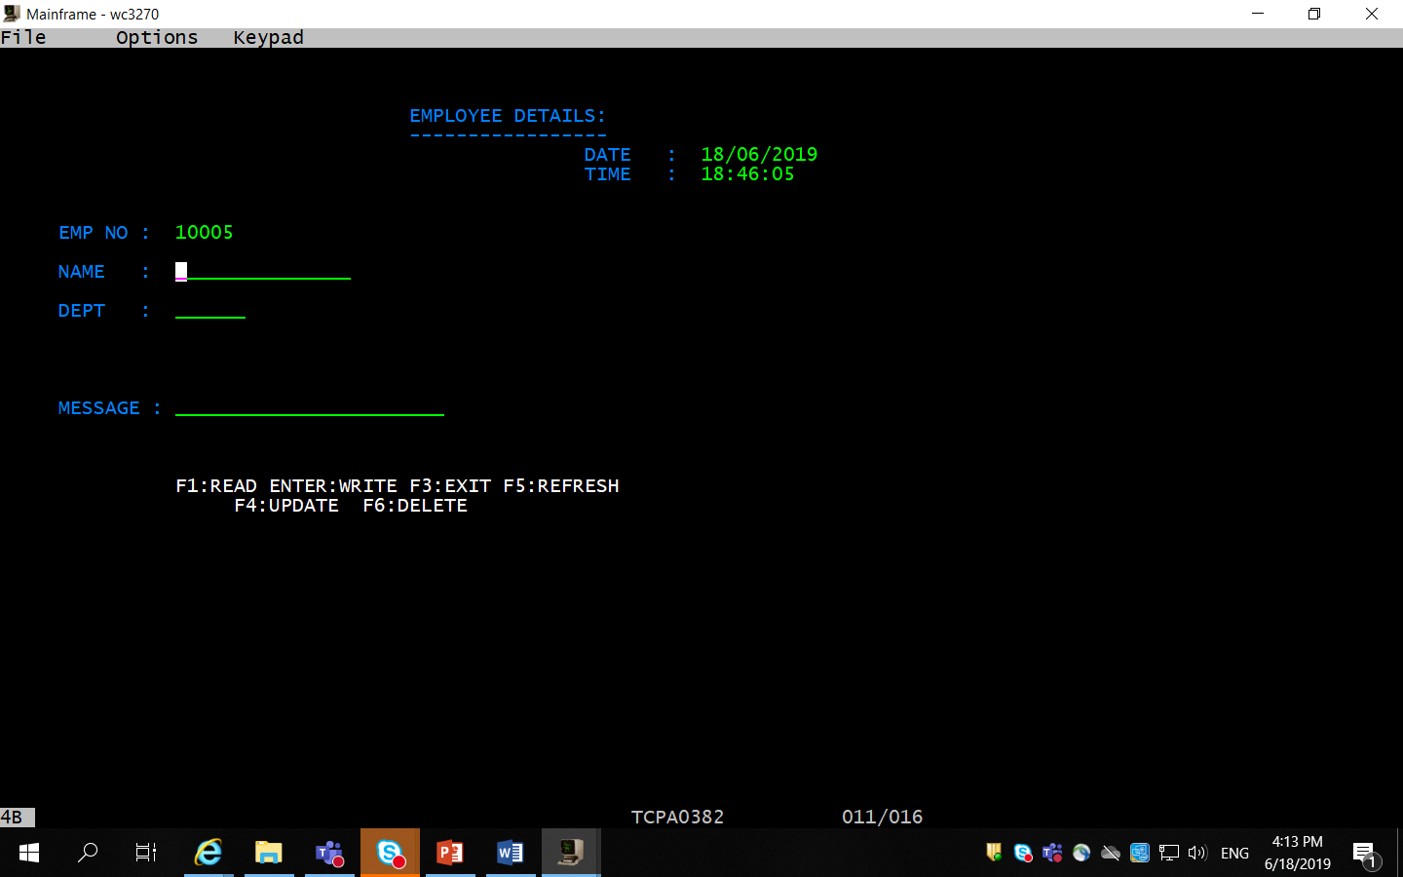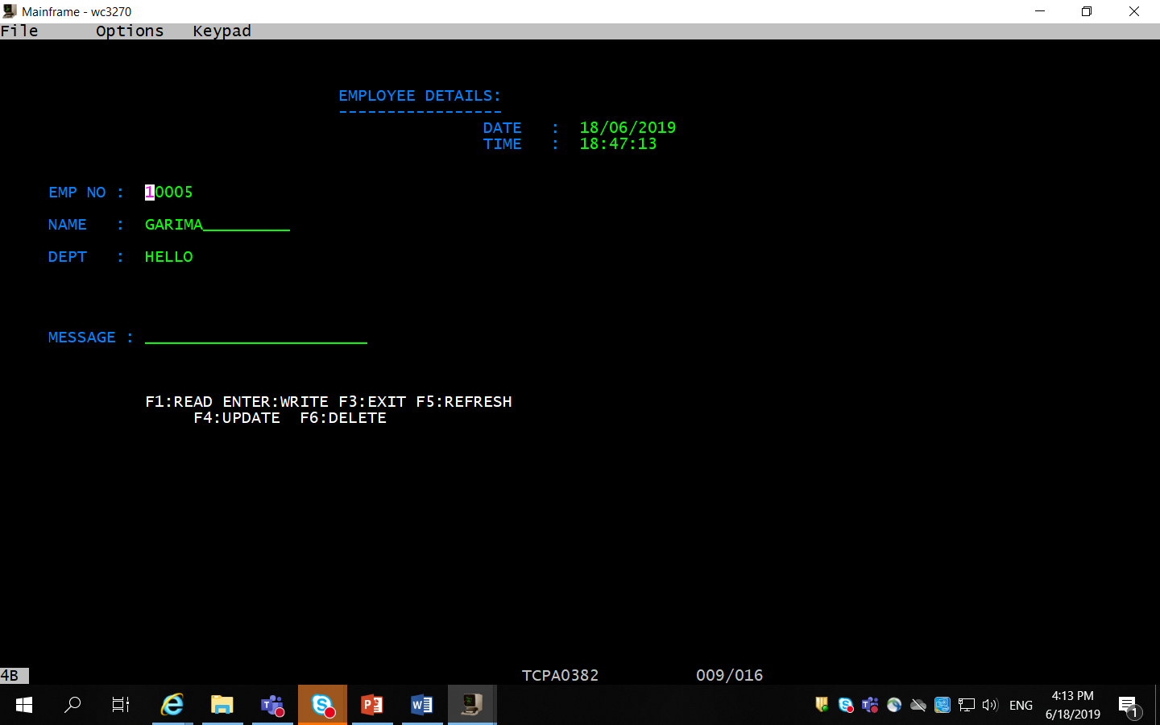

Write Record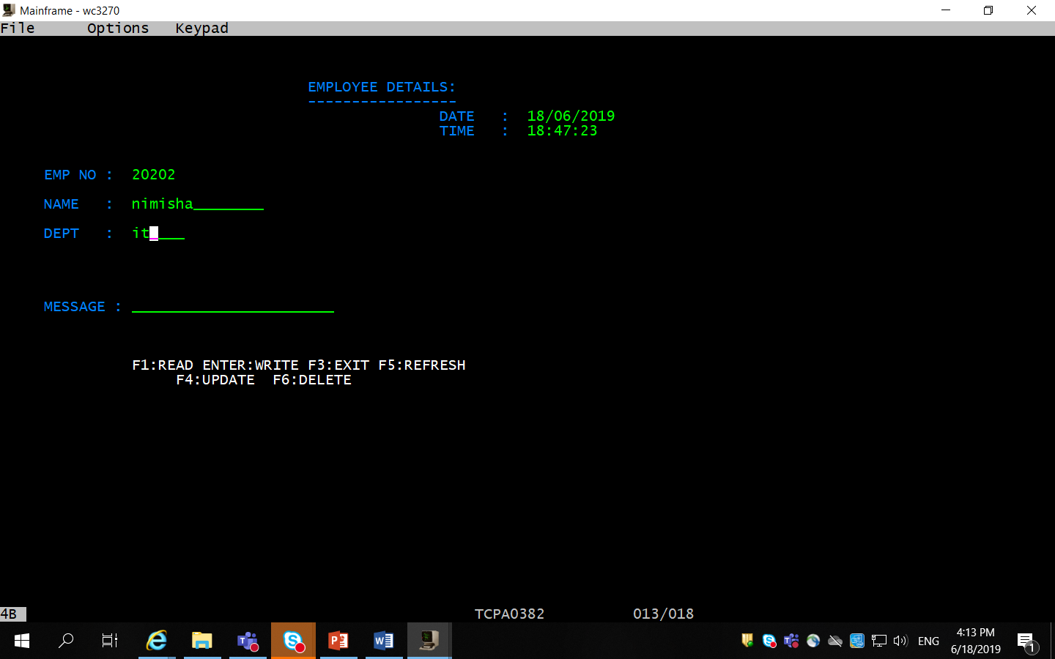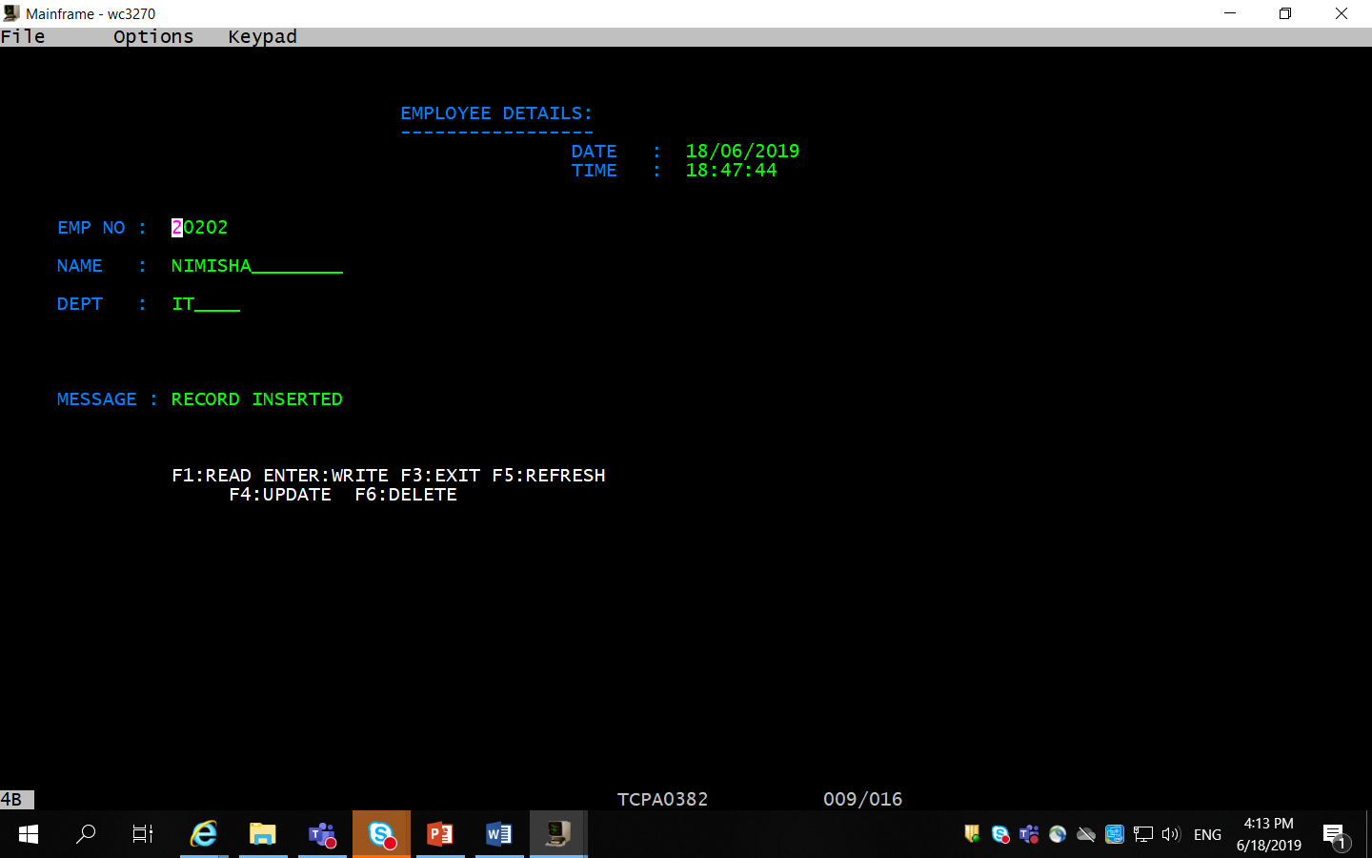

Rewrite Record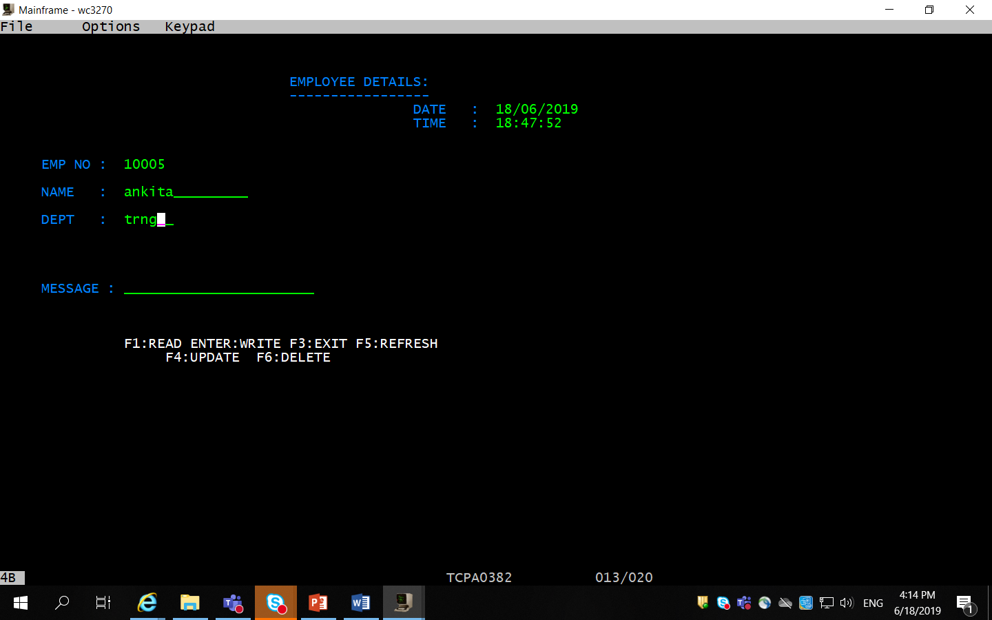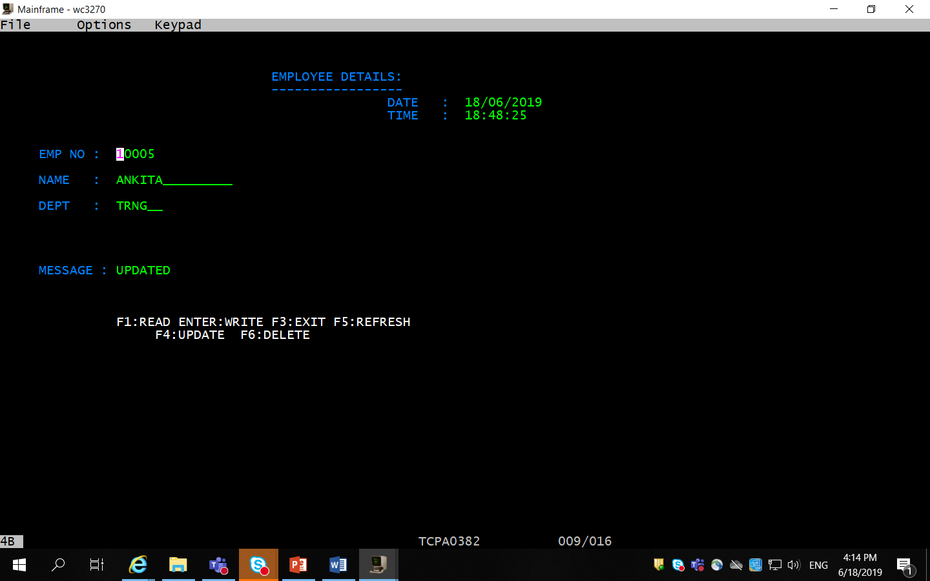

Delete Record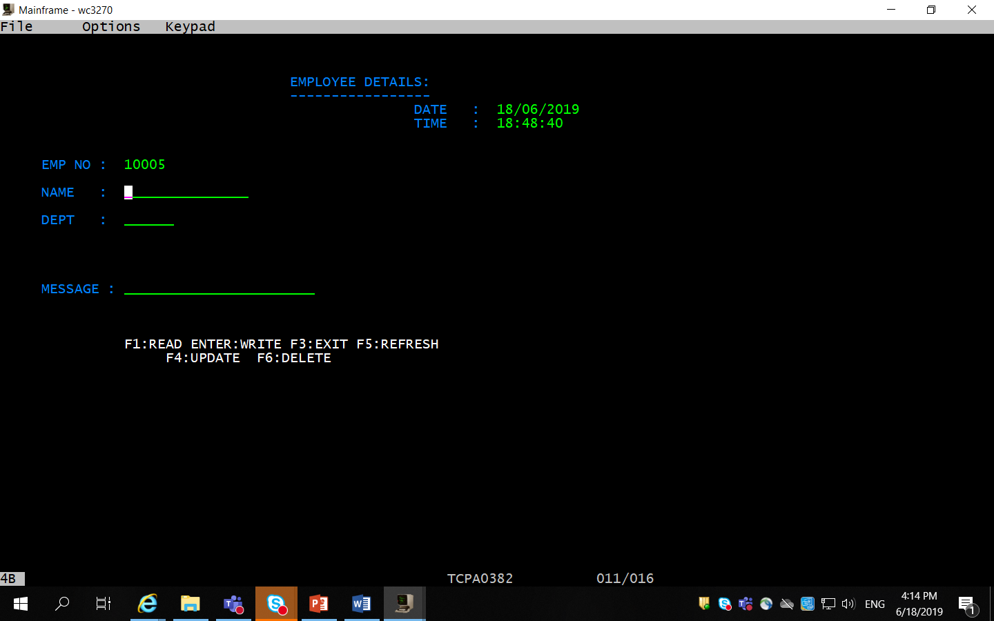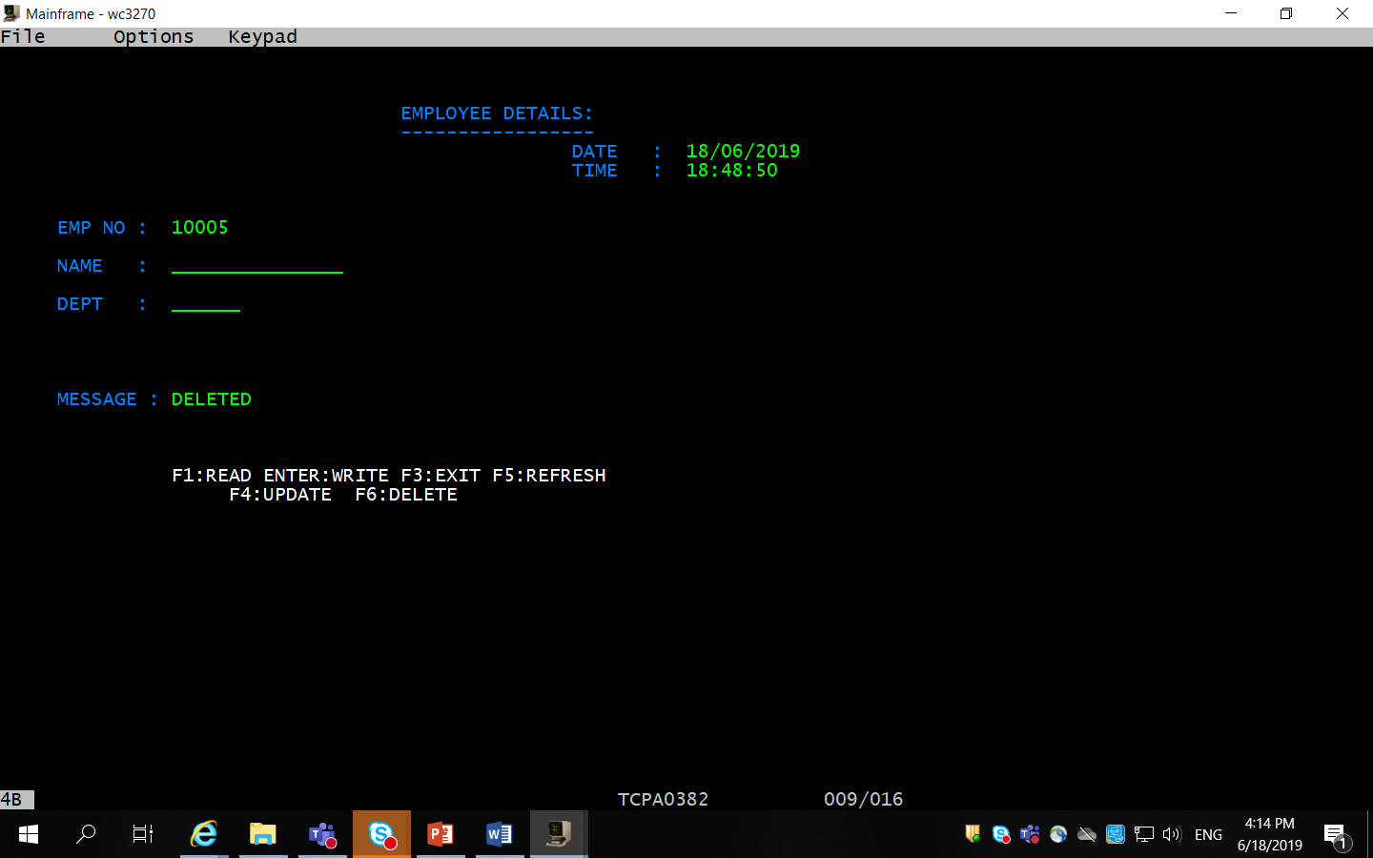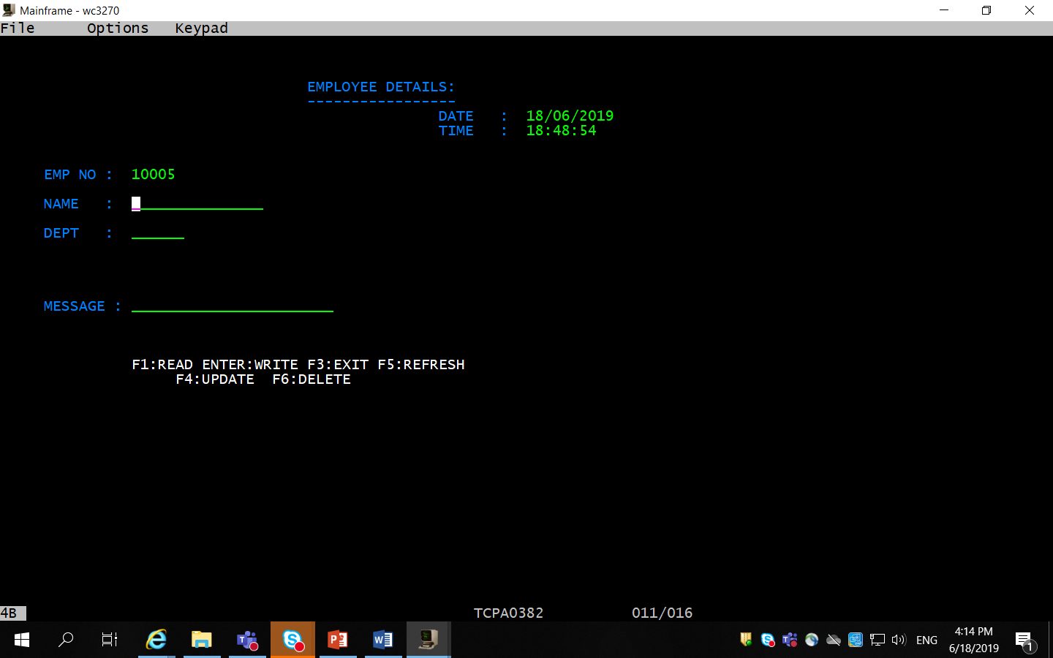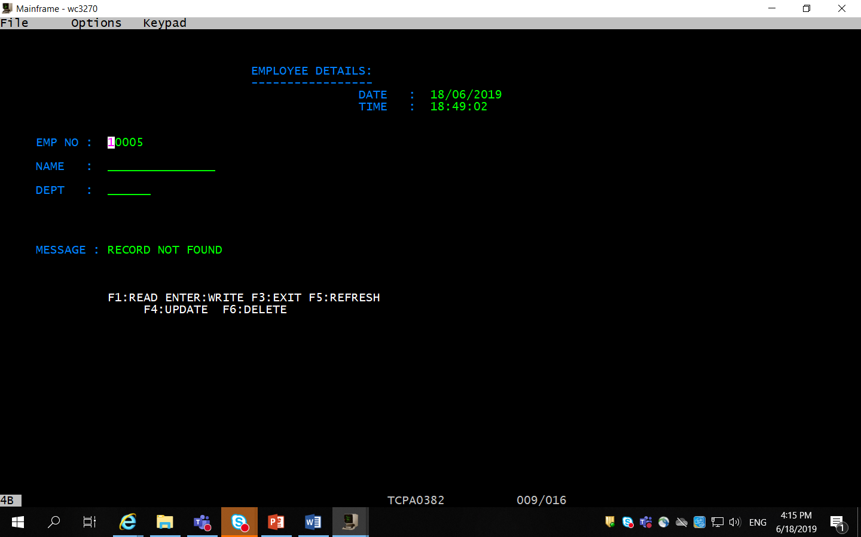

**Q4.**

**Mapset 1-**

A31MPS1 DFHMSD TYPE=&SYSPARM,MODE=INOUT,CTRL=(FREEKB,FRSET), X

LANG=COBOL,TIOAPFX=YES, X

STORAGE=AUTO

A31MPS1 DFHMDI SIZE=(24,80), X

LINE=01,COLUMN=01

DFHMDF POS=(03,20),LENGTH=17,ATTRB=PROT, X

INITIAL='EMPLOYEE DETAILS:'

DFHMDF POS=(04,20),LENGTH=17,ATTRB=PROT, X

INITIAL='-----------------'

DFHMDF POS=(05,40),LENGTH=08,ATTRB=PROT, X

INITIAL='DATE :'

DFHMDF POS=(06,40),LENGTH=10,ATTRB=PROT, *

INITIAL='TIME :'

DFHMDF POS=(11,20),LENGTH=09,ATTRB=PROT, *

INITIAL='EMP NO : '

DATE DFHMDF POS=(05,50),LENGTH=10,ATTRB=(UNPROT,NORM), X

INITIAL='__________'

TIME DFHMDF POS=(06,50),LENGTH=08,ATTRB=(UNPROT,NORM), X

INITIAL='________'

EMPNO DFHMDF POS=(11,30), X

LENGTH=05, X

ATTRB=(UNPROT,NORM,IC), X

INITIAL='_____'

MSG DFHMDF POS=(18,30), X

LENGTH=25, X

ATTRB=(UNPROT,NORM), X

INITIAL=' '

DFHMDF POS=(23,15), X

LENGTH=40, X

ATTRB=(PROT,BRT), X

INITIAL='ENTER:PROCESS F3:EXIT F5:REFRESH'

DFHMSD TYPE=FINAL

END

**Mapset 2**

A32MPS2 DFHMSD TYPE=&SYSPARM,MODE=INOUT,CTRL=(FREEKB,FRSET), X

LANG=COBOL,TIOAPFX=YES, X

STORAGE=AUTO

A32MPS2 DFHMDI SIZE=(24,80), X

LINE=01,COLUMN=01

DFHMDF POS=(03,20),LENGTH=17,ATTRB=PROT, X

INITIAL='EMPLOYEE DETAILS:'

DFHMDF POS=(04,20),LENGTH=17,ATTRB=PROT, X

INITIAL='-----------------'

DFHMDF POS=(05,40),LENGTH=08,ATTRB=PROT, X

INITIAL='DATE :'

DFHMDF POS=(06,40),LENGTH=10,ATTRB=PROT, *

INITIAL='TIME :'

DFHMDF POS=(11,20),LENGTH=09,ATTRB=PROT, *

INITIAL='EMP NO : '

DFHMDF POS=(12,20),LENGTH=09,ATTRB=PROT, *

INITIAL='NAME : '

DFHMDF POS=(13,20),LENGTH=09,ATTRB=PROT, *

INITIAL='DEPT : '

DATEA DFHMDF POS=(05,50),LENGTH=10,ATTRB=(UNPROT,NORM), X

INITIAL='__________'

TIMEA DFHMDF POS=(06,50),LENGTH=08,ATTRB=(UNPROT,NORM), X

INITIAL='________'

EMPNOA DFHMDF POS=(11,30),LENGTH=05,ATTRB=(PROT,FSET), X

INITIAL='_____'

NAMEA DFHMDF POS=(12,30),LENGTH=15,ATTRB=(UNPROT,NORM,IC,FSET), X

INITIAL=' '

DEPTA DFHMDF POS=(13,30),LENGTH=05,ATTRB=(UNPROT,NORM,FSET), X

INITIAL=' '

MSGA DFHMDF POS=(18,20), X

LENGTH=25, X

ATTRB=(UNPROT,NORM), X

INITIAL='_______________________'

DFHMDF POS=(23,15), X

LENGTH=40, X

ATTRB=(PROT,BRT), X

INITIAL='F2:UPDATE F3:EXIT F4:GO BACK F5:REFRESH'

DFHMSD TYPE=FINAL

END

**Mapset 3**

A32MPS3 DFHMSD TYPE=&SYSPARM,MODE=INOUT,CTRL=(FREEKB,FRSET), X

LANG=COBOL,TIOAPFX=YES, X

STORAGE=AUTO

A32MPS3 DFHMDI SIZE=(24,80), X

LINE=01,COLUMN=01

DFHMDF POS=(03,35),LENGTH=17,ATTRB=PROT, X

INITIAL='EMPLOYEE DETAILS:'

DFHMDF POS=(04,35),LENGTH=17,ATTRB=PROT, X

INITIAL='-----------------'

DFHMDF POS=(05,50),LENGTH=08,ATTRB=PROT, X

INITIAL='DATE :'

DFHMDF POS=(06,50),LENGTH=10,ATTRB=PROT, *

INITIAL='TIME :'

DFHMDF POS=(09,05),LENGTH=09,ATTRB=PROT, *

INITIAL='EMP NO : '

DFHMDF POS=(11,05),LENGTH=09,ATTRB=PROT, *

INITIAL='NAME :'

DFHMDF POS=(13,05),LENGTH=09,ATTRB=PROT, *

INITIAL='DEPT :'

DATE DFHMDF POS=(05,60),LENGTH=10,ATTRB=(UNPROT,NORM), *

INITIAL='__________'

TIME DFHMDF POS=(06,60),LENGTH=08,ATTRB=(UNPROT,NORM), *

INITIAL='________'

EMPNO DFHMDF POS=(09,15), X

LENGTH=05, X

ATTRB=(UNPROT,NORM,IC), X

INITIAL='_____'

DFHMDF POS=(09,21),LENGTH=1,ATTRB=ASKIP

DEPT DFHMDF POS=(13,15),LENGTH=06,ATTRB=(UNPROT,NORM), X

INITIAL='______'

DFHMDF POS=(18,05),LENGTH=09,ATTRB=PROT, X

INITIAL='MESSAGE :'

MSG DFHMDF POS=(18,15), X

LENGTH=25, X

ATTRB=(UNPROT,NORM), X

INITIAL='_______________________'

DFHMDF POS=(22,15), X

LENGTH=40, X

ATTRB=(PROT,BRT), X

INITIAL='F1:READ ENTER:WRITE F3:EXIT F5:REFRESH'

DFHMDF POS=(23,20), X

LENGTH=40, X

ATTRB=(PROT,BRT), X

INITIAL='F4:UPDATE F6:DELETE'

DFHMSD TYPE=FINAL

END

**Program 1**

IDENTIFICATION DIVISION.

PROGRAM-ID. A31PGM1

ENVIRONMENT DIVISION.

DATA DIVISION.

WORKING-STORAGE SECTION.

COPY A31MPS1.

COPY DFHAID.

01 WS-MSG PIC X(20) VALUE SPACES.

01 WS-COMM PIC 9(05).

01 WS-DATE PIC X(10).

01 WS-TIME PIC X(8).

01 WS-TSTAMP PIC S9(15) COMP-3.

01 WS-RESP PIC S9(08) COMP.

01 WS-ERR-FLAG PIC 9(01).

01 EMPREC.

05 EMPNO PIC 9(05).

05 EMPNAME PIC X(15).

05 EMPDEPT PIC X(06).

05 FILLER PIC X(54).

LINKAGE SECTION.

01 DFHCOMMAREA PIC X.

*

PROCEDURE DIVISION.

0000-MAIN-PARA.

IF EIBCALEN = 0

MOVE LOW-VALUES To A31MPS1O

PERFORM 2000-SENDPARA

PERFORM 3000-DATEPARA

PERFORM 2100-RETURNPARA

ELSE

PERFORM 1000-EVALUATPARA

END-IF.

1000-EVALUATPARA.

EVALUATE EIBAID

WHEN DFHENTER PERFORM 7010-READPARA

WHEN DFHPF5 PERFORM 4000-REFRESHPARA

WHEN DFHPF3 PERFORM 5000-EXITPARA

WHEN OTHER PERFORM 6000-ERRORPARA

END-EVALUATE.

2000-SENDPARA.

PERFORM 3000-DATEPARA.

EXEC CICS

SEND MAP('A31MPS1') MAPSET('A31MPS1')

ERASE

END-EXEC.

3000-DATEPARA.

EXEC CICS

ASKTIME ABSTIME(WS-TSTAMP)

END-EXEC.

EXEC CICS

FORMATTIME ABSTIME(WS-TSTAMP)

DDMMYYYY(WS-DATE)

DATESEP('/')

TIME(WS-TIME)

TIMESEP(':')

END-EXEC.

MOVE WS-DATE TO DATEO.

MOVE WS-TIME TO TIMEO.

2100-RETURNPARA.

EXEC CICS

RETURN TRANSID('A321') COMMAREA(WS-COMM)

END-EXEC.

4000-REFRESHPARA.

MOVE LOW-VALUES To A31MPS1O.

PERFORM 2000-SENDPARA.

PERFORM 3000-DATEPARA.

PERFORM 2100-RETURNPARA .

5000-EXITPARA.

MOVE 'THANK U' TO WS-MSG.

EXEC CICS SEND

CONTROL CURSOR(998)

ERASE

END-EXEC.

EXEC CICS SEND

FROM(WS-MSG)

END-EXEC.

EXEC CICS

RETURN

END-EXEC.

6000-ERRORPARA.

MOVE 'INVALID KEY ' TO MSGO.

PERFORM 2000-SENDPARA.

PERFORM 2100-RETURNPARA.

7010-READPARA.

EXEC CICS

RECEIVE MAP('A31MPS1') MAPSET('A31MPS1')

END-EXEC.

* PERFORM 4010-VALIDATEPARA.

MOVE EMPNOI TO EMPNO

EXEC CICS

READ FILE('A32FIL1')

INTO(EMPREC)

RIDFLD(EMPNO)

RESP(WS-RESP)

END-EXEC

IF WS-RESP = DFHRESP(NORMAL)

EXEC CICS

XCTL PROGRAM('A32PGM2')

COMMAREA(EMPNO)

END-EXEC

ELSE

MOVE 'RECORD NOT FOUND' TO MSGO

EXEC CICS

LINK PROGRAM('A32PGM2')

COMMAREA(EMPREC)

END-EXEC.

END-IF.

PERFORM 3000-DATEPARA.

PERFORM 2000-SENDPARA.

PERFORM 2100-RETURNPARA.

**Program 2**

IDENTIFICATION DIVISION.

PROGRAM-ID. A32PGM2

ENVIRONMENT DIVISION.

DATA DIVISION.

WORKING-STORAGE SECTION.

COPY A31MPS1.

COPY A32MPS2.

COPY DFHAID.

01 WS-MSG PIC X(20) VALUE SPACES.

01 WS-COMM PIC X.

01 WS-DATE PIC X(10).

01 WS-TIME PIC X(8).

01 WS-TSTAMP PIC S9(15) COMP-3.

01 WS-RESP PIC S9(08) COMP.

01 WS-RES PIC S9(08) COMP.

01 EMPREC.

05 EMPNO PIC 9(05).

05 EMPNAME PIC X(15).

05 EMPDEPT PIC X(06).

05 FILLER PIC X(54).

LINKAGE SECTION.

01 DFHCOMMAREA.

05 LK-E-NO PIC 9(05).

*

PROCEDURE DIVISION.

0000-MAIN-PARA.

IF EIBTRNID = 'A321'

MOVE LOW-VALUES TO A32MPS2O

MOVE LK-E-NO TO EMPNOAO

PERFORM 2000-SENDPARA

PERFORM 7010-READPARA

PERFORM 2100-RETURNPARA

ELSE

PERFORM 1000-EVALUATPARA.

1000-EVALUATPARA.

EVALUATE EIBAID

WHEN DFHPF2 PERFORM 7030-UPDATEPARA

WHEN DFHPF5 PERFORM 4000-REFRESHPARA

WHEN DFHPF3 PERFORM 5000-EXITPARA

WHEN DFHPF4 PERFORM 5010-GOBACKPARA

WHEN OTHER PERFORM 6000-ERRORPARA

END-EVALUATE.

2000-SENDPARA.

EXEC CICS

SEND MAP('A32MPS2') MAPSET('A32MPS2')

ERASE

END-EXEC.

3000-DATEPARA.

EXEC CICS

ASKTIME ABSTIME(WS-TSTAMP)

END-EXEC.

EXEC CICS

FORMATTIME ABSTIME(WS-TSTAMP)

DDMMYYYY(WS-DATE)

DATESEP('/')

TIME(WS-TIME)

TIMESEP(':')

END-EXEC.

MOVE WS-DATE TO DATEAO.

MOVE WS-TIME TO TIMEAO.

2100-RETURNPARA.

EXEC CICS

RETURN TRANSID('A322') COMMAREA(WS-COMM)

END-EXEC.

4000-REFRESHPARA.

MOVE LOW-VALUES TO A32MPS2O

PERFORM 2000-SENDPARA.

PERFORM 2100-RETURNPARA .

5000-EXITPARA.

MOVE 'THANK U' TO WS-MSG.

EXEC CICS SEND

CONTROL CURSOR(998)

ERASE

END-EXEC.

EXEC CICS SEND

FROM(WS-MSG)

END-EXEC.

EXEC CICS

RETURN

END-EXEC.

6000-ERRORPARA.

MOVE 'INVALID KEY ' TO MSGAO.

PERFORM 2000-SENDPARA.

PERFORM 2100-RETURNPARA.

5010-GOBACKPARA.

EXEC CICS

SEND MAP('A31MPS1') MAPSET('A31MPS1')

ERASE

END-EXEC.

EXEC CICS

RETURN TRANSID('A321') COMMAREA(WS-COMM)

END-EXEC.

7010-READPARA.

MOVE EMPNOAI TO EMPNO.

EXEC CICS

READ FILE('A32FIL1')

INTO(EMPREC)

RIDFLD(EMPNO)

RESP(WS-RESP)

END-EXEC.

IF WS-RESP = DFHRESP(NORMAL)

MOVE EMPNO TO EMPNOAO

MOVE EMPNAME TO NAMEAO

MOVE EMPDEPT TO DEPTAO

ELSE

MOVE 'RECORD NOT FOUND' TO MSGAO

END-IF.

PERFORM 3000-DATEPARA.

PERFORM 2000-SENDPARA.

PERFORM 2100-RETURNPARA.

7030-UPDATEPARA.

EXEC CICS

RECEIVE MAP('A32MPS2') MAPSET('A32MPS2')

END-EXEC.

MOVE EMPNOAI TO EMPNO.

EXEC CICS

READ FILE('A32FIL1')

INTO(EMPREC)

RIDFLD(EMPNO)

UPDATE

RESP(WS-RESP)

END-EXEC.

IF WS-RESP = DFHRESP(NORMAL)

MOVE EMPNOAI TO EMPNO

MOVE NAMEAI TO EMPNAME

MOVE DEPTAI TO EMPDEPT

EXEC CICS

REWRITE FILE('A32FIL1')

FROM(EMPREC)

RESP(WS-RES)

END-EXEC

IF WS-RES = DFHRESP(NORMAL)

MOVE 'UPDATED' TO MSGAO

ELSE

MOVE 'ERROR IN UPDATION' TO MSGAO

END-IF.

PERFORM 3000-DATEPARA.

PERFORM 2000-SENDPARA.

PERFORM 2100-RETURNPARA.

1. Read Record

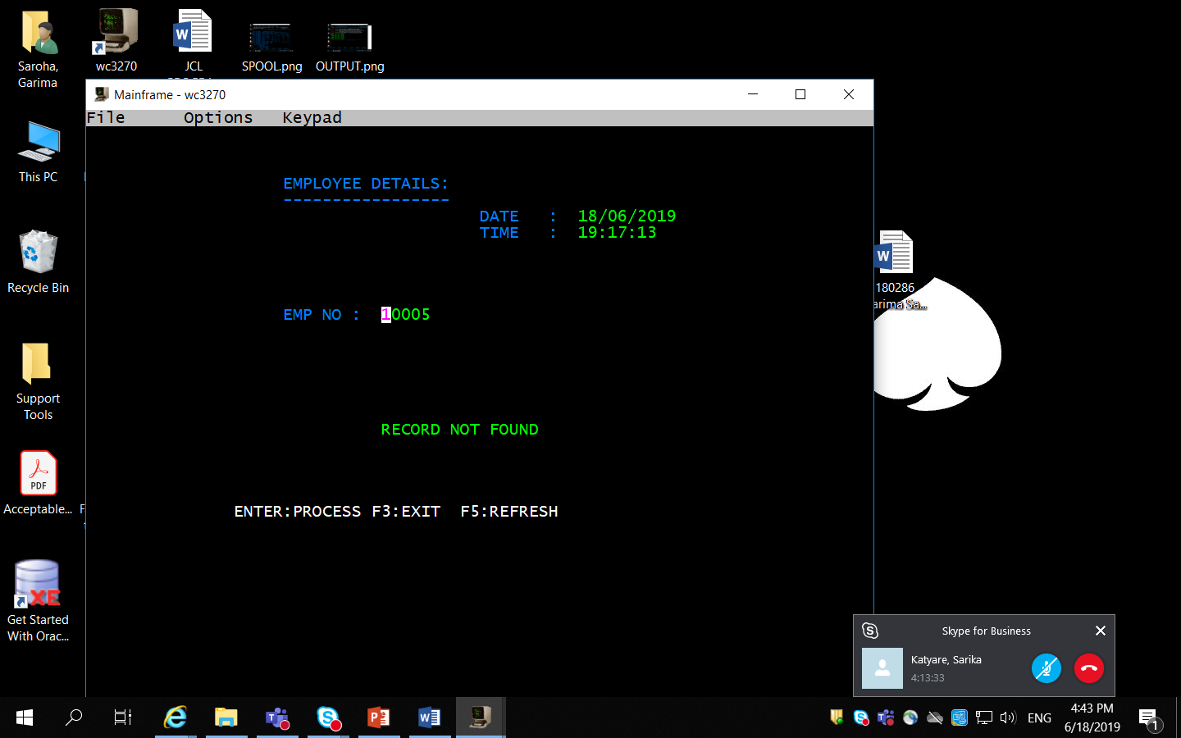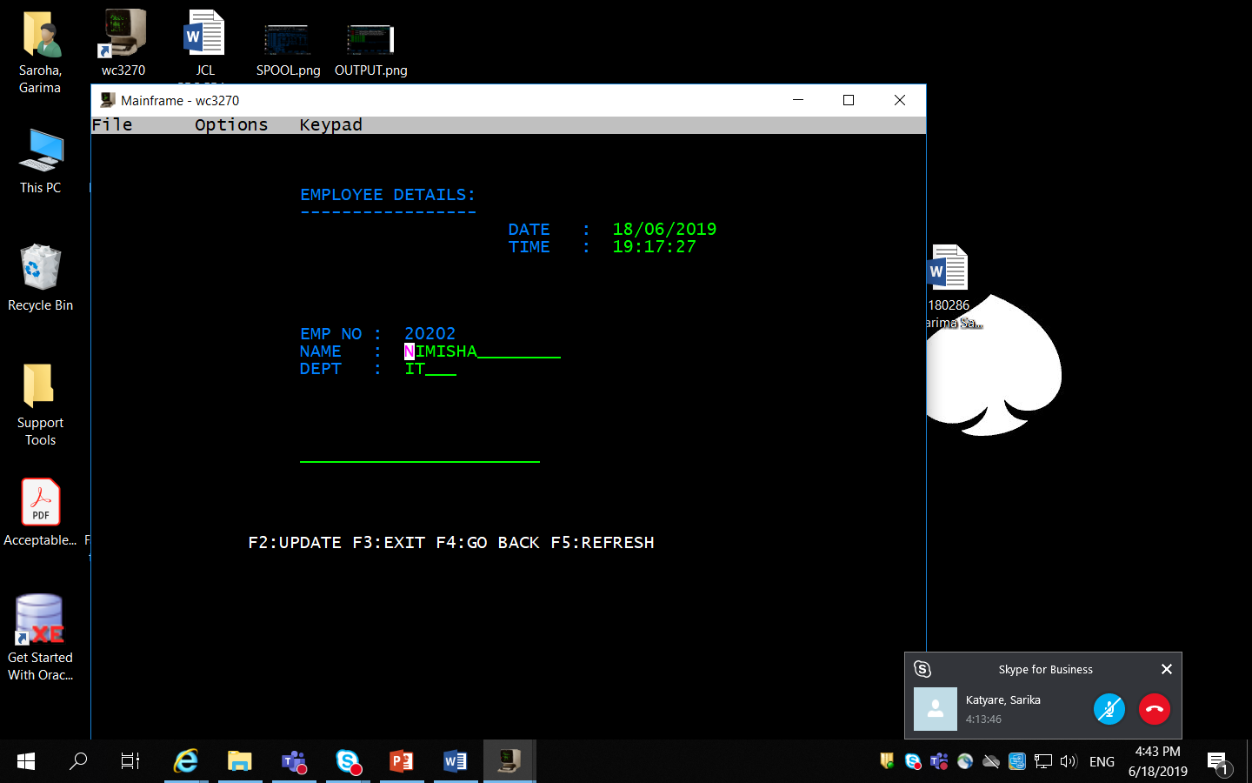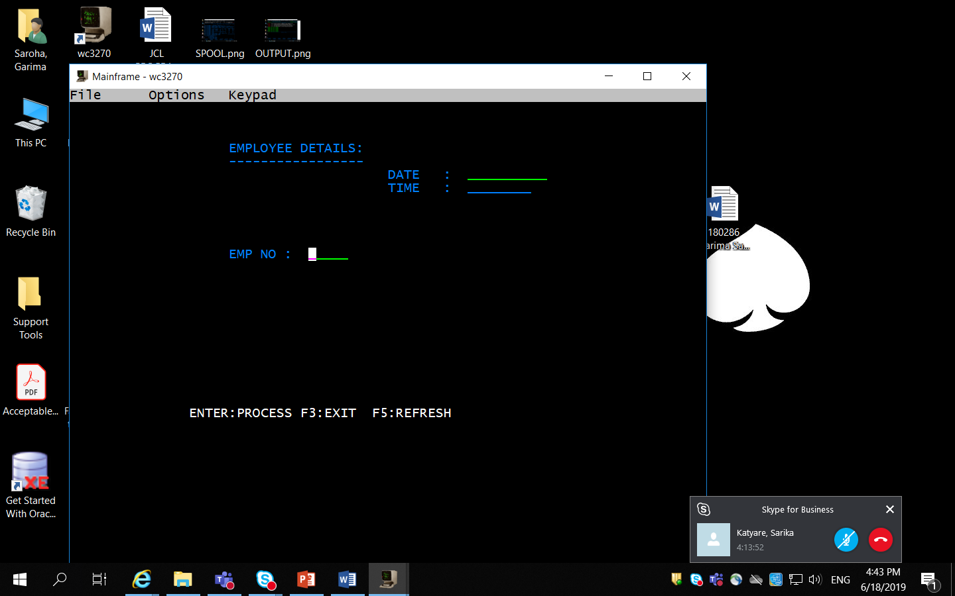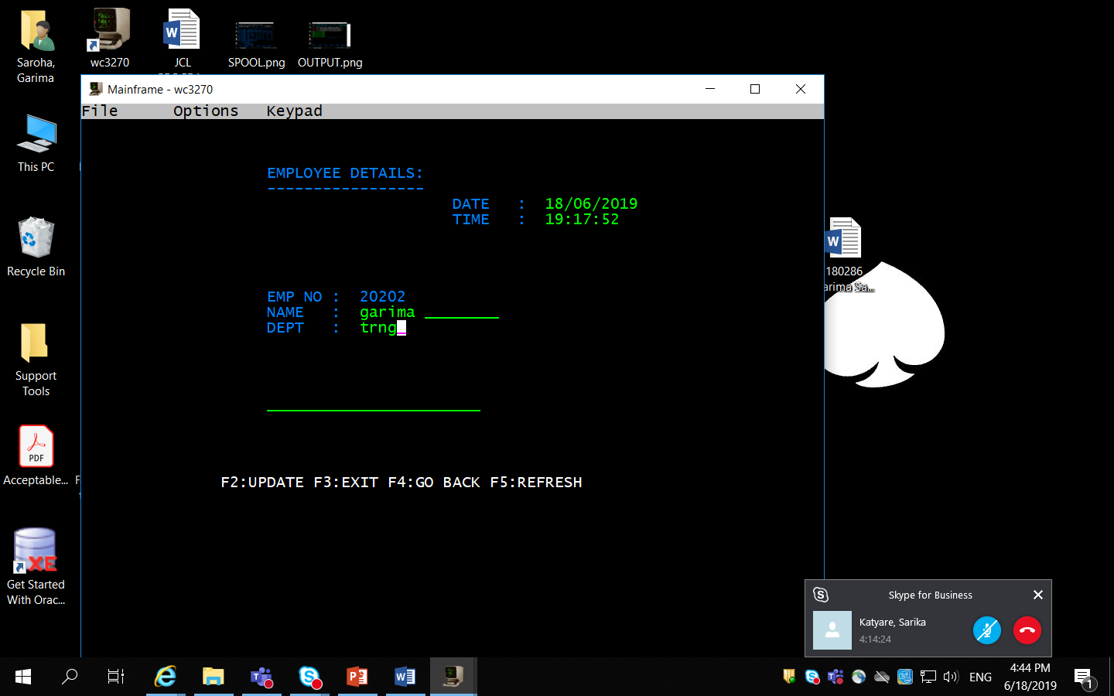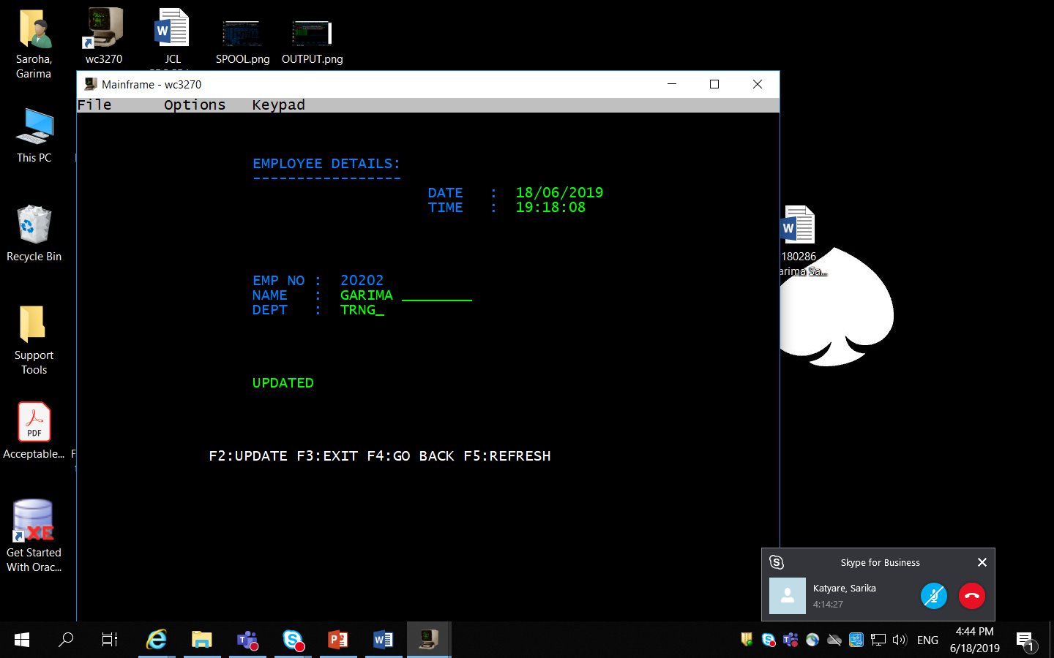

**Q5.**

**MAPSET:**

A31MPS1 DFHMSD TYPE=&SYSPARM,MODE=INOUT,CTRL=(FREEKB,FRSET), X

LANG=COBOL,TIOAPFX=YES, X

STORAGE=AUTO

A31MPS1 DFHMDI SIZE=(24,80), X

LINE=01,COLUMN=01

DFHMDF POS=(03,20),LENGTH=20,ATTRB=PROT, X

INITIAL='WELCOME TO CAPGEMINI'

DFHMDF POS=(04,20),LENGTH=20,ATTRB=PROT, *

INITIAL='*********************'

DFHMDF POS=(08,15),LENGTH=08,ATTRB=PROT, *

INITIAL='DATE :'

DATE DFHMDF POS=(08,24), X

LENGTH=10, X

INITIAL='__________', X

ATTRB=(UNPROT,NORM,IC)

DFHMDF POS=(08,35),LENGTH=01,ATTRB=ASKIP

DFHMDF POS=(10,15),LENGTH=08,ATTRB=PROT, X

INITIAL='TIME :'

TIME DFHMDF POS=(10,24), X

LENGTH=08, X

INITIAL='________', X

ATTRB=(UNPROT,NORM)

DFHMDF POS=(10,33),LENGTH=01,ATTRB=PROT

DFHMDF POS=(14,15),LENGTH=09,ATTRB=PROT, X

INITIAL='MESSAGE :'

MSGA DFHMDF POS=(14,25), X

LENGTH=25, X

INITIAL='_________________________', X

ATTRB=(UNPROT,NORM)

DFHMDF POS=(20,10), X

LENGTH=40, X

INITIAL='F3:EXIT ENTER:RETRIEVE DATE F5:REFRESH', X

ATTRB=(PROT,BRT)

DFHMSD TYPE=FINAL

END

**Program**

IDENTIFICATION DIVISION.

PROGRAM-ID. A32PGM3.

************************************************

* handling

************************************************

ENVIRONMENT DIVISION.

DATA DIVISION.

WORKING-STORAGE SECTION.

COPY A31MPS1.

COPY DFHAID.

01 WS-MSG PIC X(20) VALUE SPACES.

01 WS-COMM PIC X.

01 WS-DATE PIC X(10).

01 WS-TIME PIC X(8).

01 WS-TSTAMP PIC S9(15) COMP-3.

LINKAGE SECTION.

01 DFHCOMMAREA PIC X.

*

PROCEDURE DIVISION.

0000-MAIN-PARA.

IF EIBCALEN = 0

MOVE LOW-VALUES To A31MPS1O

PERFORM 2000-SENDPARA

PERFORM 2100-RETURNPARA

ELSE

PERFORM 1000-EVALUATPARA.

1000-EVALUATPARA.

EXEC CICS HANDLE CONDITION

MAPFAIL(6000-ERRORPARA)

END-EXEC.

EVALUATE EIBAID

WHEN DFHPF5 PERFORM 4000-REFERSHPARA

WHEN DFHPF3 PERFORM 5000-EXITPARA

WHEN DFHPF12 PERFORM 3000-DATEPARA

WHEN OTHER PERFORM 6000-ERRORPARA

END-EVALUATE.

2000-SENDPARA.

EXEC CICS

SEND MAP('A31MPS1') MAPSET('A31MPS1')

ERASE

END-EXEC.

2100-RETURNPARA.

EXEC CICS

RETURN TRANSID('A321') COMMAREA(WS-COMM)

END-EXEC.

4000-REFERSHPARA.

MOVE LOW-VALUES To A31MPS1O

PERFORM 2000-SENDPARA .

PERFORM 2100-RETURNPARA .

5000-EXITPARA.

MOVE 'THANK U' TO WS-MSG.

EXEC CICS

SEND FROM(WS-MSG)

ERASE

END-EXEC.

EXEC CICS

RETURN

END-EXEC.

6000-ERRORPARA.

MOVE 'INVALID NUM ' TO MSGAO.

PERFORM 2000-SENDPARA.

PERFORM 2100-RETURNPARA.

3000-DATEPARA.

MOVE LOW-VALUES TO A31MPS1O

EXEC CICS

ASKTIME ABSTIME(WS-TSTAMP)

END-EXEC.

EXEC CICS

FORMATTIME ABSTIME(WS-TSTAMP)

DDMMYYYY(WS-DATE)

DATESEP('/')

TIME(WS-TIME)

TIMESEP(':')

END-EXEC.

MOVE WS-DATE TO DATEO.

MOVE WS-TIME TO TIMEO.

PERFORM 2000-SENDPARA.

PERFORM 2100-RETURNPARA.

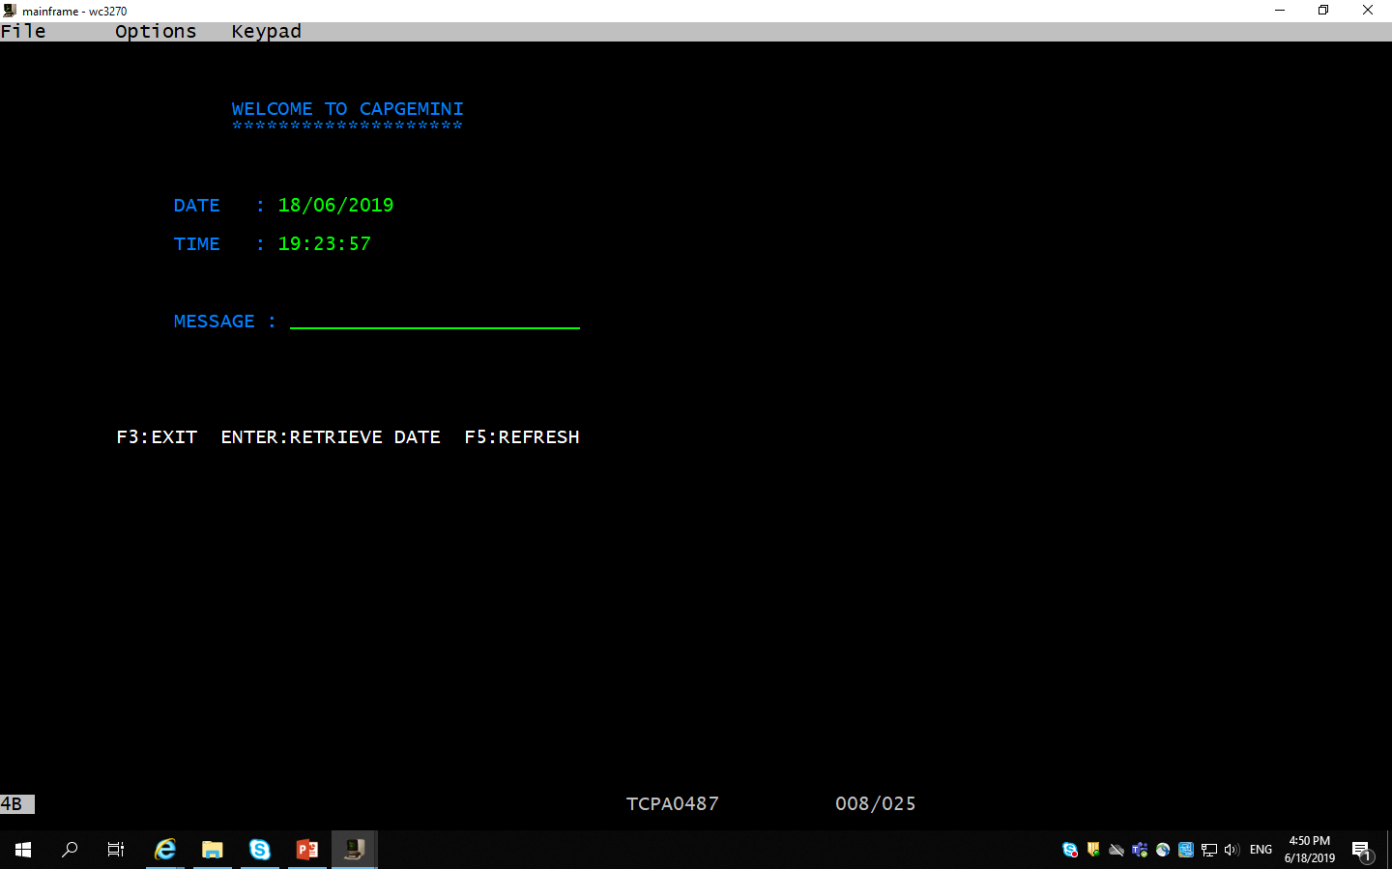

**Q6.**

IDENTIFICATION DIVISION.

       PROGRAM-ID. A01PGM3.

      *

       ENVIRONMENT DIVISION.

      *

       DATA DIVISION.

       WORKING-STORAGE SECTION.

       77 WS-TXT          PIC   X(20) VALUE 'ENTER TWO NO'.

       01 WS-INPUT.

         05 WS-NUM1       PIC   9(03).

         05 WS-NUM2       PIC   9(03).

       01 WS-OUTPUT.

         05 WS-TEXT       PIC   X(08).

         05 WS-RES        PIC   9(04).

      *

       PROCEDURE DIVISION.

            EXEC CICS

                 SEND

                 FROM (WS-TXT)

                 LENGTH (LENGTH OF WS-TXT)

                 ERASE

         END-EXEC.

            EXEC CICS

                 RECEIVE

                 INTO (WS-INPUT)

                 LENGTH (LENGTH OF WS-INPUT)

            END-EXEC.

            MOVE 'OUTPUT :' TO WS-TEXT.

            COMPUTE WS-RES = WS-NUM1 + WS-NUM2.

            EXEC CICS

                 SEND

                 FROM (WS-OUTPUT)

                 LENGTH (LENGTH OF WS-OUTPUT)

                 ERASE

            END-EXEC.

            EXEC CICS

                 RETURN

            END-EXEC.

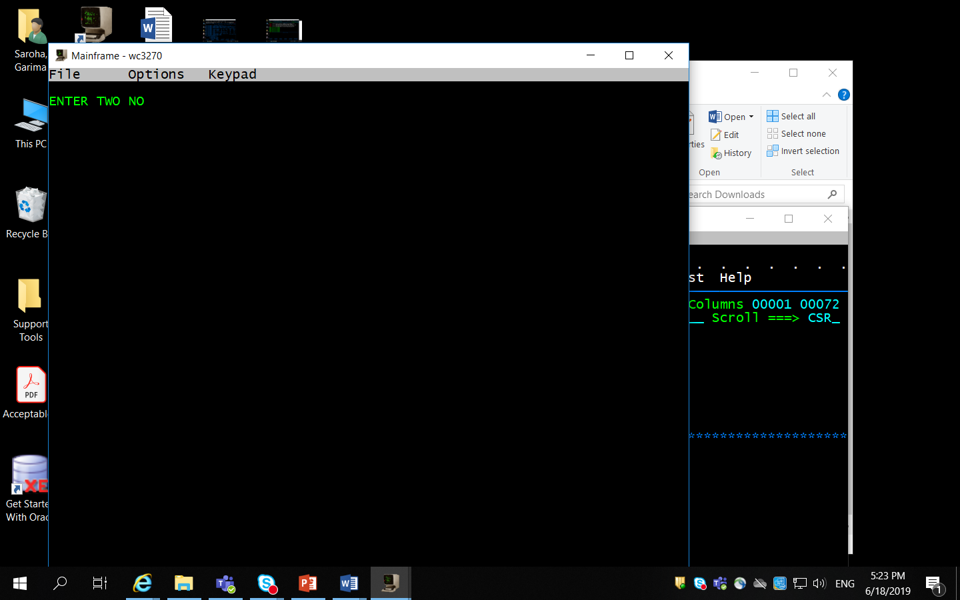

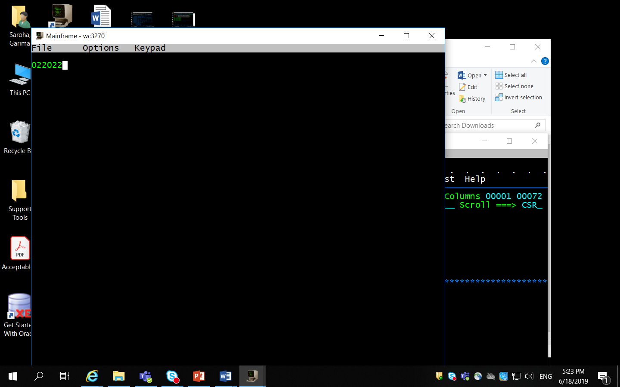

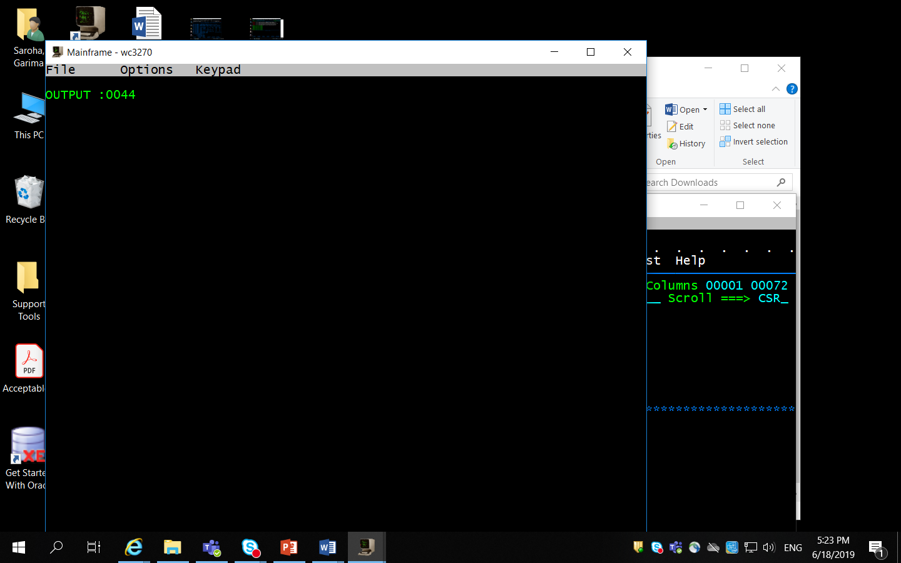

Q7.